CHAPTER - 1
SYNOPSIS

This project is aimed at developing a software useful for student below 5th grade. TODDLER is a VB.Net application that can be accessed throughout the students. This software is useful to learn information quickly about natural items like fruits, vegetables, animals and birds. The software is mainly developed for children usage and developed in a manner that is easily manageable, time saving and relieving one from manual works. Nowadays children have lots of interest in computers, so this is a good way to study.

Here we have only two Modules and some of Sub - Module in the software,
- Learn
- Fruits
- Vegetables
- Animals
- Birds
- Manipulation (Edit)
- Login
- Category Selection
- Add new
- Save
- Update
- Delete

CHAPTER – 2
INTRODUCTION
INTRODUCTION
The "TODDLER" has been developed to override the problems prevailing in the practicing manual system. This software is supported to eliminate and in some cases reduce the hardships faced by this existing system. Moreover this system is designed for the particular need of the children under 5th Grade.
The application is reduced as much as possible to avoid man power and cost of the products. No formal knowledge is needed for the user to use this system. Thus by this all it proves it is user-friendly.
TODDLER, as described above, can lead to error free, secure, reliable and fast management system. It can assist the user to concentrate on the record of the chart or notebook.
Thus it will help teachers and parent in better utilization of resources. Every organization, whether big or small, has challenges to overcome and managing the Records.
This is designed to assist in strategic planning, and will help you ensure that your organization is equipped with the right level of information and details.
Also, for those busy executive who are always on the go, our systems come with remote access features, which will allow you to manage your workforce anytime, at all times. These systems will ultimately allow you to better manage resources.

CHAPTER - 3
SYSTEM ALAYSIS
3.1 EXISTING SYSTEM

Process of existing is done by manually. All the needed information of a items are fetched by the teachers or parents.
The students want to learn the particular subject, they should wait for long time because work done manually.
This type of teaching is not only teach by the teacher also teach by the parent using the chart or board.
In the existing system of the process teachers and parents have a chart or board with picture to teach. Or else student have saw the picture, they teach by using that.
I as mentioned previously, today there exist some computer program which helps user to find and learn basic information such as fruits, vegetable, animal and birds
Rest all the computational work either needs a different program or is done manually by faculties of that institution.
- Lack of security of data.
- More man power.
- Time consuming.
- Consumes large volume of pare work.
- Needs manual collection of data records.
- No direct role for the higher officials.

3.1.1 DRAWBACKS OF EXISTING SYSTEM

The main drawback of the system is data loss. The hard copy document or booklet of the note book is misplaced or any type of damage can occur, we will loss the data.
By this process student have boring on their study because of the usual process of study
It has a lot of the time waste and also has man power waste. We have to save the documents for the particular category.
Teachers spend days on each student to teach the varieties of the data.
This is an extremely time-consuming process that is also prone to human errors.
This system is very time taking process and the data can’t be accessed accurately.
If there any uneducated parents child or not go through them in their home.

3.2 PROPOSED SYSTEM

The proposed system for “TOODLER” replacing the manual work of the teachers and parents.
This application is portable and can easily access by the staffs. Time taken for getting the information will be reduces.
The drawback which are faced in the existing system is overcame by using the proposed system.
The system which is proposed now computerized all the details that are maintained manually.
By this proposed system the teaching is completely diffrenent from the ordinary process.
The student have some excitement while this type of learn.
Proposed approach and its advantage over existing system:
    - User friendly
    - ALL time availability
    - Easy Storage of data.
    - More efficient.
    - Requires less effort and time.
    - Security of data.
    - Minimize manual data entry.
    - Minimum time needed for the various processing.
    - Greater efficiency.
    - Better service.
    - User friendliness and interactive.
    - Minimum time required.
    - Student have better viewpoint
    - Children have better

3.2.1 FEATURES OF PROPOSED SYSTEM

In this software just give the input of the item information and save their data then it save for a long time. And also the give the inputs for the details, then it automatically stored on the database.
Using learn button on the dashboard user should go to the learn page.
Using edit button on the dashboard user should go to the edit page after the perfect login page.
If there is any error, the message box is notify that. So we will change that very easily.
- Product and Component based
- Creating & Changing Issues at ease
- Query Issue List to any depth
- Reporting & Charting in more comprehensive way
- User Accounts to control the access and maintain security
- Simple Status & Resolutions
- Multi-level Priorities & Severities.
- Targets & Milestones for guiding the programmers
- Attachments & Additional Comments for more information
- Robust database back-end
- Various level of reports available with a lot of filter criteria’s
- It contain better storage capacity.
- Easy & fast retrieval of information.
- Decrease the load of the person involve in existing manual system.
- Access of any information individually.
- Work becomes very speedy.
- Easy to update information

CHAPTER – 4
SYSTEM ENVIRONMENT
SYSTEM ENVIRONMENT
4.1 HARDWARE SPECIFICATION

• Processor :: AMD PRO A4-4350B
• Ram :: 4 GB
• Hard Disk :: 500 GB
• Monitor :: 14 inches LCD
•Mouse :: Zook gaming BLADE mouse

4.2 SOFTWARE SPECIFICATION

• Operating System :: Windows 11
• Language :: VB.Net
• Name of the software :: Visual Studio 2022
• Database :: Ms Access

CHAPTER - 5
SYSTEM DESIGN
SYSTEM DESIGN
5.1 DATA FLOW DIAGRAM

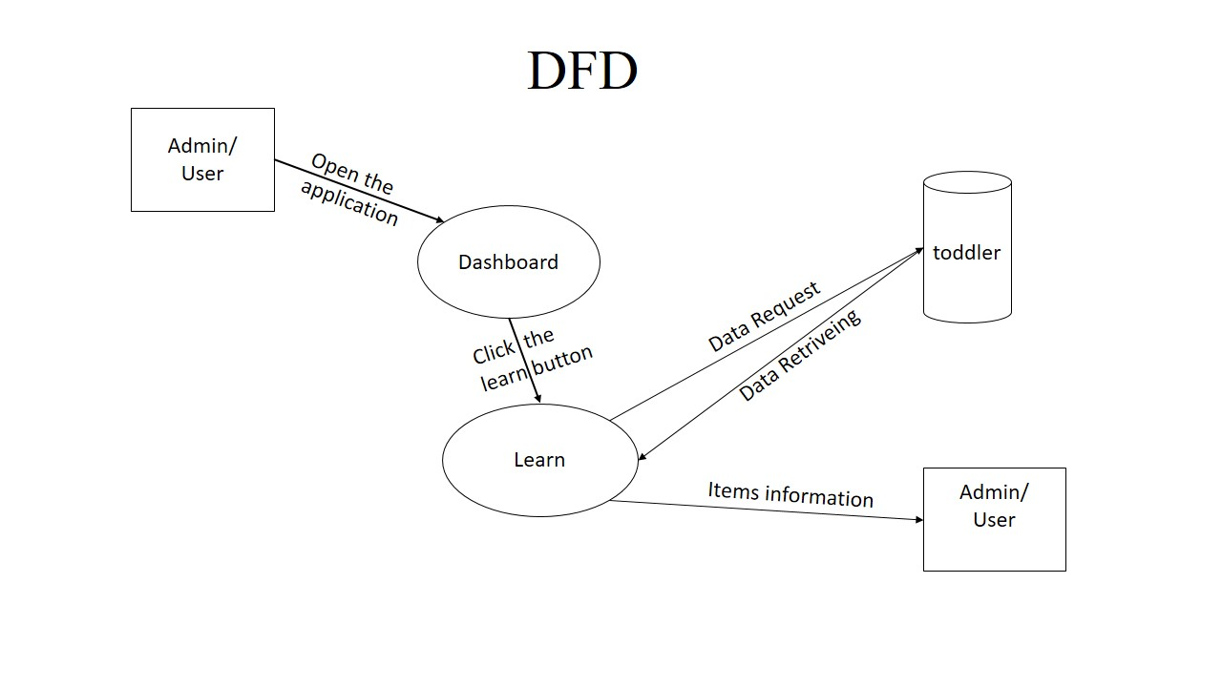
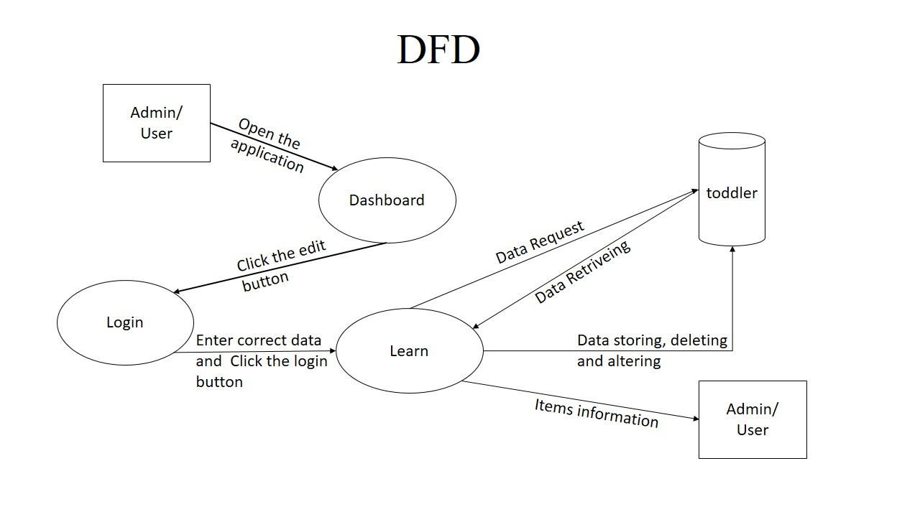

5.2 DASHBOARD DESIGN

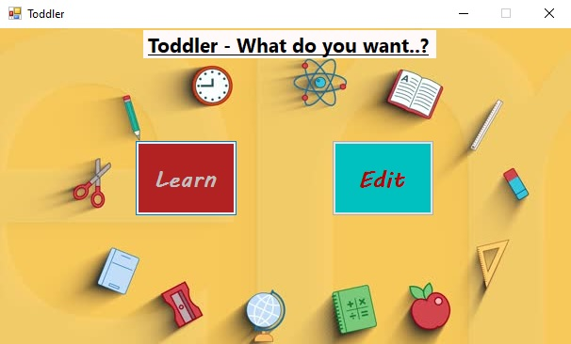

DASHBOARD PAGE

This is the actual screenshot of the dashboard page.
It contain,
  - A label is used to display the message
  - Two buttons can be used,one is for “Learn” and another one is “Edit”.
Work of the button:
Learn - Go to Learn page
Edt - Go to edit page

5.3 INPUT DESIGN

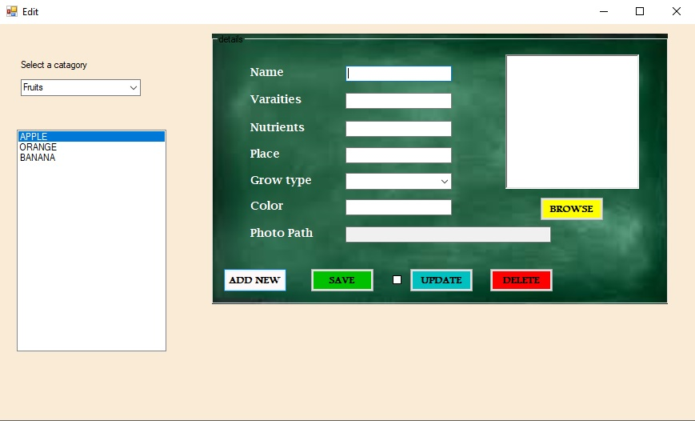

INPUT SCREEN

This is the actual screenshot of the data input screen
It contains,
  - Some of label boxes can be used for display some message.
  - 5 textboxes can be used for entering the input.
- 2 comboboxes for select the particular list values.
- Select category - to select the category like fruti, vegetable, animal and fruit
- Grow type - to select the growtype like tree, plan, vine
- command buttons,
    - Addnew - to clear the textboxes for new input
    - Save - to save the enter value to the database
    - Update - to update what to you want
    - Delete - to delete a record on the database
A checkbox can be used for switch to update option.

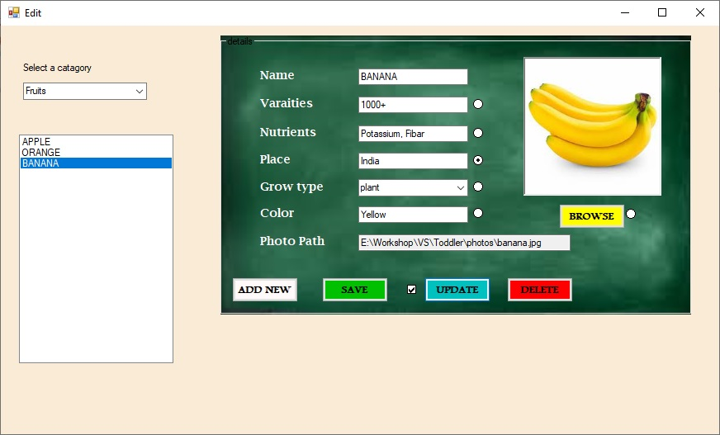

UPDATION SCREEN

This is the actual screenshot of update screen.
First check the updation check box to enable update option.
It contain,
This is also as like as the input screen.
For additionally here some of Radio button,
    - Radio button near the varieties text box - to update varieties
    - Radio button near the nutrients text box - to update nutrients
    - Radio button near the place text box - to update place
    - Radio button near the grow type combo box - to update grow type
    - Radio button near the color text box - to update color
    - Radio button near the browse button - to update picture

After check the Radio button enter the data to change and click on the “update” button.

5.4 OUTPUT DESIGN

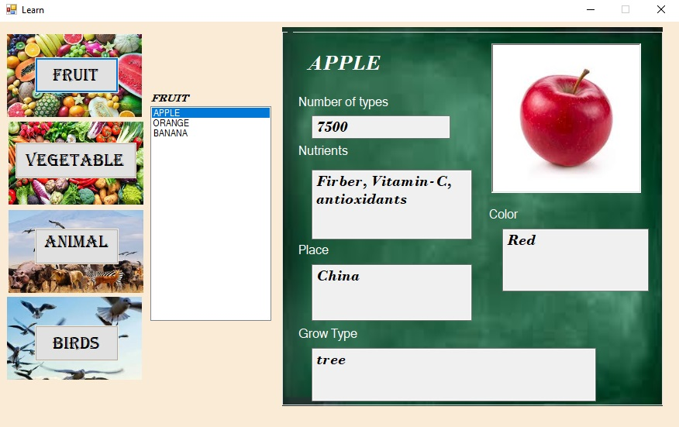

FRUIT INFORMATION VIEWER SCREEN

This is the actual acreenshot of the fruit information viewer
It contains,
  - Some of the labels can be used for display message.
  - One listbox can be used to select a item form the name of the fruit.
  - text box can be used display value.
  - A picture box to show the image of the fruit.
  - Four command button to select the category link fruit, vegetable, animal and birds

Other screenshots are attested below..(Vegetable, Animal, Birds)

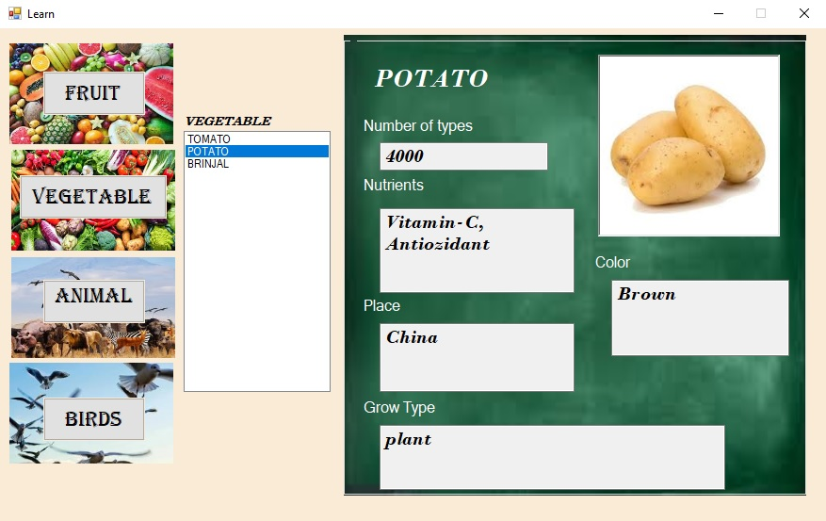

VEGETABLE INFORMATION VIEWER SCREEN

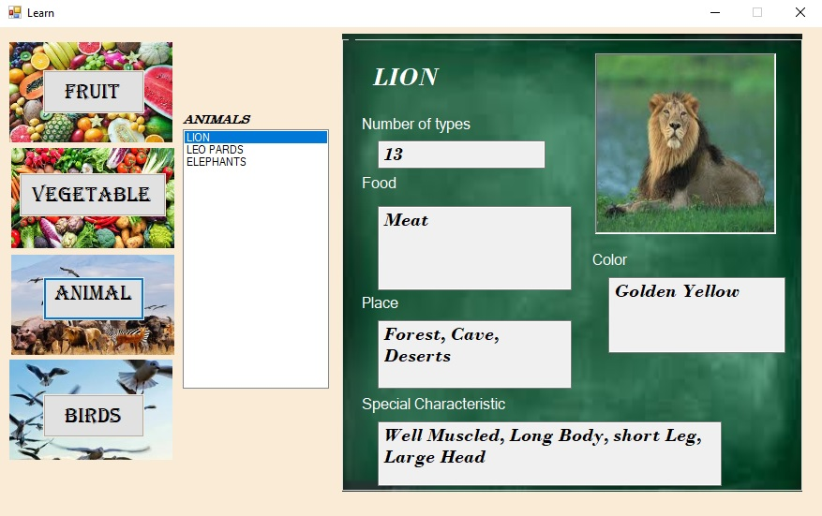

ANIMAL INFORMATION VIEWER SCREEN
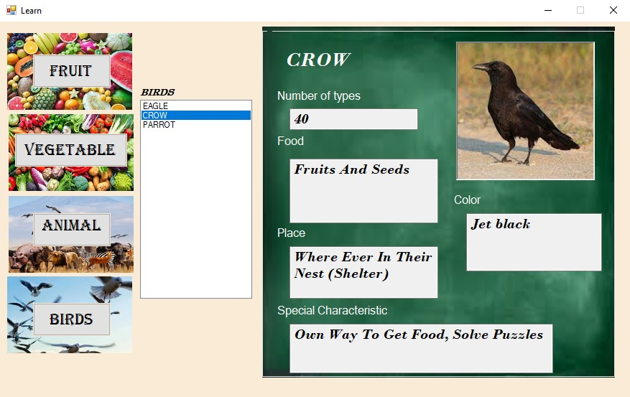

BIRDS INFORMATION VIEWER SCREEN

These are the output screens to display the details about the selected category.

5.5 DATABASE DESIGN

TABLE 1: fruit

Field Name | Data Type
name | Short text
varieties | Short text
nutrients | Short text
place | Short text
growtype | Short text
photo | Long text
color | Short text

TABLE 2: vegetable

Field Name | Data Type
name | Short text
varieties | Short text
nutrients | Short text
place | Short text
growtype | Short text
photo | Long text
color | Short text

TABLE 3: animal

Field Name | Data Type
name | Short text
varieties | Short text
sc | Short text
place | Short text
food | Short text
photo | Long text
color | Short text

TABLE 4: bird

Field Name | Data Type
name | Short text
varieties | Short text
Sc | Short text
place | Short text
food | Short text
photo | Long text
color | Short text

CHAPTER – 6
SYSTEM DESCRIPTION
MODULES DESCRIPTION

- DASHBOARD
- LEARN
- FRUIT
- VEGETABLE
- ANIMAL
- BIRDS
- MANIPULATION(EDIT)
- LOGIN
- Category Selection
- Add new
- Save
- Update
- Delete

DASHBOARD
Here this module is used to select the where you would like to go.
For example, if you are a student you have to select “learn” to study, else you are a teacher or parent then you have to “edit” to manipulate the data stored on the database

LEARN
This module is used to Display items information. Here also we have the some sub-module to select the category, by this option you have select the category like fruits, vegetable, animal and birds. Here the list of sub-module, here I mention the command button as a sub-module.
Fruit - to display the details of fruits
Vegetable - to display the details of vegetable
Animal - to display the details of animal
Birds - to display the details of birds

MANIPUATION (EDIT)
This module is used to add new item, save the particular item, update the particular set of the value and delete the particular item from the database. Here also we have the some sub-module to select the category, by this option you have select the category like fruits, vegetable, animal and birds. Here the list of sub-module,
Login - this login access is used to verify that you are the admin
Category selection - to select the particular category like fruit,
vegetable, animal and fruit.
COMMAND BUTTONS AS SUB-MODLE
addnew - this button is used to add new item at the table
save - this button is used to save item
update - this button is used to update a particular item at the table
delete - this button is used to delete a item from the table

CHAPTER – 7
TESTING
TESTING TECHNOLOGIES
System Testing
System testing, or end-to-end testing, tests a completely integrated system to verify that it meets its requirements.
For example, a system test might involve testing a logon interface, then creating and editing an entry, plus sending or printing results, followed by summary processing or deletion (or archiving) of entries, then logoff.

Unit Testing
Unit testing, also known as component testing, refers to tests that verify the functionality of a specific section of code, usually at the function level.
In an object-oriented environment, this is usually at the class level, and the minimal unit tests include the constructors and destructors.
These types of tests are usually written by developers as they work on code (white-box style), to ensure that the specific function is working as expected.

System Testing
System testing is the first level in which the complete application is tested as a whole.
The goal at this level is to evaluate whether the system has complied with all of the outlined requirements and to see that it meets Quality Standards.
System testing is undertaken by independent testers who haven’t played a role in developing the program.

User Input Validation Testing
The User input must be validated to confirm to expected values. The fields should also not be empty.

Testcase for the dashboard form
Test case | Test description | Test step | Expected result | Actual result | status
TC-1 | Open learn form when click the learn button | Click the learn button | Open the learn form | Learn form opened | Success
TC-2 | Don’t open edit form when click the learn button | Click the learn button | Don’t open the edit form | Learn form opened | success
TC-3 | Open edit form when click the edit button | Click the edit button | Open the edit form | Edit form opened | Success
TC-4 | Don’t open learn form when click the edit button | Click the edit button | Don’t open the learn form | Learn form opened | success

Testcase for the learn form
Test case | Test description | Test step | Expected result | Actual result | status
TC-1 | List out all of the fruit items in listbox when click the fruit button | Click the fruit button | List out fruits in listbox | Fruit items are displayed in listbox | Success
TC-2 | List out all of the vegetable items in listbox when click the vegetable | Click the vegetable button | List out vegetable in listbox | vegetable items are displayed in listbox | Success
TC-3 | List out all of the animal items in listbox when click the animal button | Click the animal button | List out animal in listbox | animal items are displayed in listbox | Success
TC-4 | List out all of the birds items in listbox when click the bird button | Click the bird button | List out birds in listbox | birds items are displayed in listbox | Success
TC-5 | On the right side, show the details of the selected item from the list box | Select a item from the listbox | Show the details of the selected item | Selected item details are visible | Success

Testcase for the login form
Test case | Test description | Test step | Expected result | Actual result | status
TC-1 | If the checkbox is checked the password text are visible to the user | Enter data on password textbox and check the checkbox | Password textbox text are visible to the user | Text are visible to the user | Success
TC-2 | If the checkbox is unchecked the password text are visible to the user | Enter data on password textbox without check the checkbox | Password textbox text are not visible to the user | Text are not visible to the user | Success
TC-3 | Go to the previous page when click the back button without any other operation | Click the back button | Open the previous page | Previous page opened without any other operation | success
TC-4 | Go to the next page when click the login button with correct data | Enter correct data and click the login button | Open the next page | Next page opened | success

Testcase for the edit form
Test case | Test description | Test step | Expected result | Actual result | status
TC-1 | List out all of the fruit items in listbox when when select fruit in combobox | Select fruit in the combobox | List out fruits in listbox | Fruit items are displayed in listbox | Success
TC-2 | List out all of the vegetable items in listbox when select vegetable in combobox | Select vegetable in the combobox | List out vegetable in listbox | vegetable items are displayed in listbox | Success
TC-3 | List out all of the animal items in listbox when select animal in combobox | Select animal in the combobox | List out animal in listbox | animal items are displayed in listbox | Success
TC-4 | List out all of the birds items in listbox when select bird in combobox | Select bird in the combobox | List out birds in listbox | birds items are displayed in listbox | Success
TC-5 | On the right side, show the details of the selected item from the list box | Select a item from the listbox | Show the details of the selected item | Selected item details are visible | Success
TC-6 | Open addnew section when click the addnew button | Click the addnew button | Make empty all the input boxes | All input boxes are empty | Success
TC-7 | Save input details on the selected database when click the save button | Click the save button | Save data on the database and show a message like saved | Data saved and message showed | Success
TC-8 | Update the selected set on the selected database when click the update button | Select set and click the update button | update data on the database and show a message like updated | Data updated and message showed | Success
TC-9 | Delete the selected record on database when click the delete button | Select a item and click the delete button | Delete the selected data on the database and show a message like deleted | Record deleted and message showed | Success

CHAPTER - 8
SAMPLE CODING
SAMPLE CODING
Coding for the Dashboad page

Public Class Form1
Code for form_closed
Private Sub Form1_FormClosed(ByVal sender As System.Object, ByVal e As System.Windows.Forms.FormClosedEventArgs) Handles MyBase.FormClosed
Application.Exit()
End Sub
Code for learn button
Private Sub Button1_Click(ByVal sender As System.Object, ByVal e As System.EventArgs) Handles Button1.Click
Form2.Show()
End Sub
Code for edit button
Private Sub Button2_Click(ByVal sender As System.Object, ByVal e As System.EventArgs) Handles Button2.Click
Form3.Show()
End Sub
Code for form_load
Private Sub Form1_Load(ByVal sender As System.Object, ByVal e As System.EventArgs) Handles MyBase.Load
MaximizeBox = False
End Sub
End Class

Coding for the learn form
Imports System.IO
Imports System.Data.OleDb

Code for fruit buttton
Private Sub Button1_Click(ByVal sender As System.Object, ByVal e As System.EventArgs) Handles Button1.Click
Label1.Text = Button1.Text
lbfruit.Visible = True
lbveg.Visible = False
lbanimal.Visible = False
lbbird.Visible = False
Label3.Text = "Nutrients"
Label6.Text = "Grow Type"
Dim str1 As String
Dim cmd1 As New OleDbCommand
cn.Open()
str1 = "select name from fruit"
cmd1 = New OleDbCommand(str1, cn)
cmd1.ExecuteNonQuery()
cn.Close()
Dim da As New OleDbDataAdapter(cmd1)
Dim dt As New DataTable
da.Fill(dt)
lbfruit.DataSource = dt
lbfruit.DisplayMember = "name"

End Sub

Code for vegetable button
Private Sub Button2_Click(ByVal sender As System.Object, ByVal e As System.EventArgs) Handles Button2.Click
Label1.Text = Button2.Text
lbfruit.Visible = False
lbveg.Visible = True
lbanimal.Visible = False
lbbird.Visible = False
Label3.Text = "Nutrients"
Label6.Text = "Grow Type"
Dim str1 As String
Dim cmd1 As New OleDbCommand
cn.Open()
str1 = "select name from veg"
cmd1 = New OleDbCommand(str1, cn)
cmd1.ExecuteNonQuery()
cn.Close()
Dim da As New OleDbDataAdapter(cmd1)
Dim dt As New DataTable
da.Fill(dt)
lbveg.DataSource = dt
lbveg.DisplayMember = "name"
End Sub

Code for animal button
Private Sub Button3_Click(ByVal sender As System.Object, ByVal e As System.EventArgs) Handles Button3.Click
Label1.Text = Button3.Text
lbfruit.Visible = False
lbveg.Visible = False
lbanimal.Visible = True
lbbird.Visible = False
Label3.Text = "Food"
Label6.Text = "Special Characteristic"
Dim str1 As String
Dim cmd1 As New OleDbCommand
cn.Open()
str1 = "select name from animal"
cmd1 = New OleDbCommand(str1, cn)
cmd1.ExecuteNonQuery()
cn.Close()
Dim da As New OleDbDataAdapter(cmd1)
Dim dt As New DataTable
da.Fill(dt)
lbanimal.DataSource = dt
lbanimal.DisplayMember = "name"
End Sub

Code for bird button
Private Sub Button4_Click(ByVal sender As System.Object, ByVal e As System.EventArgs) Handles Button4.Click
Label1.Text = Button4.Text
lbfruit.Visible = False
lbveg.Visible = False
lbanimal.Visible = False
lbbird.Visible = True
Label3.Text = "Food"
Label6.Text = "Special Characteristic"
Dim str1 As String
Dim cmd1 As New OleDbCommand
cn.Open()
str1 = "select name from bird"
cmd1 = New OleDbCommand(str1, cn)
cmd1.ExecuteNonQuery()
cn.Close()
Dim da As New OleDbDataAdapter(cmd1)
Dim dt As New DataTable
da.Fill(dt)
lbbird.DataSource = dt
lbbird.DisplayMember = "name"
End Sub

Code for fruit list box
Private Sub lbfruit_SelectedIndexChanged(ByVal sender As Object, ByVal e As System.EventArgs) Handles lbfruit.SelectedIndexChanged

lbname.Text = lbfruit.Text
cn.Open()
Dim str4 As String = "select * from fruit where name = '" & lbname.Text & "'"
Dim cmd4 As New OleDbCommand(str4, cn)
Dim myreader As OleDbDataReader
myreader = cmd4.ExecuteReader
If myreader.Read Then
tbvar.Text = myreader("varieties").ToString
tbnut.Text = myreader("nutrients").ToString
tbplace.Text = myreader("place").ToString
tbgt.Text = myreader("growtype").ToString
tbpath.Text = myreader("photo").ToString
tbcolor.Text = myreader("color").ToString
PictureBox1.Image = Image.FromFile(tbpath.Text)
End If
cn.Close()
End Sub

Coding for the login form
Public Class Form3
Code for form_load
Private Sub Form3_Load(ByVal sender As System.Object, ByVal e As System.EventArgs) Handles MyBase.Load
Form1.Visible = False
TextBox1.Text = ""
TextBox2.Text = ""
MaximizeBox = False
End Sub
Code for form_close
Private Sub Form3_FormClosed(ByVal sender As System.Object, ByVal e As System.Windows.Forms.FormClosedEventArgs) Handles MyBase.FormClosed
Form1.Visible = True
End Sub

Code for check box
Private Sub CheckBox1_CheckedChanged(ByVal sender As System.Object, ByVal e As System.EventArgs) Handles CheckBox1.CheckedChanged
If CheckBox1.Checked = True Then
TextBox2.UseSystemPasswordChar = False
Else
TextBox2.UseSystemPasswordChar = True
End If
End Sub

Code for back button
Private Sub Button2_Click(ByVal sender As System.Object, ByVal e As System.EventArgs) Handles Button2.Click
Form1.Show()
Me.Close()

End Sub
Code for login button
Private Sub Button1_Click(ByVal sender As System.Object, ByVal e As System.EventArgs) Handles Button1.Click
If TextBox1.Text = "thaniga" And TextBox2.Text = "2002" Then
Form4.Show()
Me.Visible = False
Else
MsgBox("check the details")

End If
End Sub
End Class

Coding for the login form
Imports System.IO
Imports System.Data.OleDb

Public Class Form4
Dim cn As New OleDbConnection("Provider=Microsoft.ACE.OLEDB.12.0;Data Source=E:\Workshop\VS\Toddler\toddler.accdb")

Private Sub Form4_FormClosed(ByVal sender As System.Object, ByVal e As System.Windows.Forms.FormClosedEventArgs) Handles MyBase.FormClosed
Form1.Visible = True
MaximizeBox = False
End Sub
Coding for the picture box
Private Sub Button1_Click(ByVal sender As System.Object, ByVal e As System.EventArgs) Handles Button1.Click
Using img1 As OpenFileDialog = New OpenFileDialog

img1.Filter = "choose image(*.jpg;*.png;*.gif)|*.jpg;*.png;*.gif"

If img1.ShowDialog() = DialogResult.OK Then
tbpath.Text = Path.GetFullPath(img1.FileName)

PictureBox1.Image = Image.FromFile(img1.FileName)
End If

End Using
End Sub

Coding for the clear button
Private Sub Button2_Click(ByVal sender As System.Object, ByVal e As System.EventArgs) Handles Button2.Click
tbname.Text = ""
tbcolor.Text = ""
tbnut.Text = ""
tbpath.Text = ""
tbplace.Text = ""
tbvar.Text = ""
tbsc.Text = ""
cbgt.SelectedItem = Nothing
PictureBox1.Image = Nothing

End Sub
Coding for the combo box selection
Private Sub cbcatalog_SelectedIndexChanged(ByVal sender As System.Object, ByVal e As System.EventArgs) Handles cbcatalog.SelectedIndexChanged
tbname.Text = ""
tbcolor.Text = ""
tbnut.Text = ""
tbpath.Text = ""
tbplace.Text = ""
tbvar.Text = ""
tbsc.Text = ""
cbgt.SelectedItem = Nothing
PictureBox1.Image = Nothing

If cbcatalog.SelectedIndex = 0 Then
Dim str1 As String
Dim cmd1 As New OleDbCommand
cn.Open()
str1 = "select name from fruit"
cmd1 = New OleDbCommand(str1, cn)
cmd1.ExecuteNonQuery()
cn.Close()
Dim da As New OleDbDataAdapter(cmd1)
Dim dt As New DataTable
da.Fill(dt)
lbitems.DataSource = dt
lbitems.DisplayMember = "name"

ElseIf cbcatalog.SelectedIndex = 1 Then
Dim str1 As String
Dim cmd1 As New OleDbCommand
cn.Open()
str1 = "select name from veg"
cmd1 = New OleDbCommand(str1, cn)
cmd1.ExecuteNonQuery()
cn.Close()
Dim da As New OleDbDataAdapter(cmd1)
Dim dt As New DataTable
da.Fill(dt)
lbitems.DataSource = dt
lbitems.DisplayMember = "name"
ElseIf cbcatalog.SelectedIndex = 2 Then
Dim str1 As String
Dim cmd1 As New OleDbCommand
cn.Open()
str1 = "select name from animal"
cmd1 = New OleDbCommand(str1, cn)
cmd1.ExecuteNonQuery()
cn.Close()
Dim da As New OleDbDataAdapter(cmd1)
Dim dt As New DataTable
da.Fill(dt)
lbitems.DataSource = dt
lbitems.DisplayMember = "name"
ElseIf cbcatalog.SelectedIndex = 3 Then
Dim str1 As String
Dim cmd1 As New OleDbCommand
cn.Open()
str1 = "select name from bird"
cmd1 = New OleDbCommand(str1, cn)
cmd1.ExecuteNonQuery()
cn.Close()
Dim da As New OleDbDataAdapter(cmd1)
Dim dt As New DataTable
da.Fill(dt)
lbitems.DataSource = dt
lbitems.DisplayMember = "name"
Else
gbfruit.Visible = False
End If

If cbcatalog.SelectedIndex = 0 Then
tbsc.Visible = False
cbgt.Visible = True
gbfruit.Visible = True
l3.Text = "Nutrients"
l5.Text = "Grow type"

ElseIf cbcatalog.SelectedIndex = 1 Then
tbsc.Visible = False
cbgt.Visible = True
gbfruit.Visible = True
l3.Text = "Nutrients"
l5.Text = "Grow type"

ElseIf cbcatalog.SelectedIndex = 2 Then
cbgt.Visible = False
gbfruit.Visible = True
tbsc.Visible = True
l3.Text = "Food"
l5.Text = "Spcial Characters"

ElseIf cbcatalog.SelectedIndex = 3 Then
cbgt.Visible = False
gbfruit.Visible = True
tbsc.Visible = True
l3.Text = "Food"
l5.Text = "Spcial Characters"

Else
gbfruit.Visible = False
End If
End Sub
Coding for formload
Private Sub Form4_Load(ByVal sender As System.Object, ByVal e As System.EventArgs) Handles MyBase.Load
gbfruit.Visible = False

End Sub

Coding for the save button
Private Sub Button3_Click(ByVal sender As System.Object, ByVal e As System.EventArgs) Handles Button3.Click
If cbcatalog.SelectedIndex = 0 Then
Dim str As String
Dim cmd As New OleDbCommand
cn.Open()
str = "insert into fruit(name,varieties,nutrients,place,growtype,photo,color) values ('" & tbname.Text & "','" & tbvar.Text & "','" & tbnut.Text & "','" & tbplace.Text & "','" & cbgt.Text & "','" & tbpath.Text & "','" & tbcolor.Text & "')"
cmd = New OleDbCommand(str, cn)
cmd.ExecuteNonQuery()
MsgBox("added")
cn.Close()
ElseIf cbcatalog.SelectedIndex = 1 Then
Dim str As String
Dim cmd As New OleDbCommand
cn.Open()
str = "insert into veg(name,varieties,nutrients,place,growtype,photo,color) values ('" & tbname.Text & "','" & tbvar.Text & "','" & tbnut.Text & "','" & tbplace.Text & "','" & cbgt.Text & "','" & tbpath.Text & "','" & tbcolor.Text & "')"
cmd = New OleDbCommand(str, cn)
cmd.ExecuteNonQuery()
MsgBox("added")
cn.Close()
ElseIf cbcatalog.SelectedIndex = 2 Then
Dim str As String
Dim cmd As New OleDbCommand
cn.Open()
str = "insert into animal(name,varieties,food,place,sc,photo,color) values ('" & tbname.Text & "','" & tbvar.Text & "','" & tbnut.Text & "','" & tbplace.Text & "','" & tbsc.Text & "','" & tbpath.Text & "','" & tbcolor.Text & "')"
cmd = New OleDbCommand(str, cn)
cmd.ExecuteNonQuery()
MsgBox("added")
cn.Close()

ElseIf cbcatalog.SelectedIndex = 3 Then
Dim str As String
Dim cmd As New OleDbCommand
cn.Open()
str = "insert into bird(name,varieties,food,place,sc,photo,color) values ('" & tbname.Text & "','" & tbvar.Text & "','" & tbnut.Text & "','" & tbplace.Text & "','" & tbsc.Text & "','" & tbpath.Text & "','" & tbcolor.Text & "')"
cmd = New OleDbCommand(str, cn)
cmd.ExecuteNonQuery()
MsgBox("added")
cn.Close()
End If
End Sub

Coding for the delete button
Private Sub Button5_Click(ByVal sender As System.Object, ByVal e As System.EventArgs) Handles Button5.Click
If cbcatalog.SelectedIndex = 0 Then
Dim str2 As String
Dim cmd2 As New OleDbCommand
cn.Open()
str2 = "delete from fruit where name='" & tbname.Text & " '"
cmd2 = New OleDbCommand(str2, cn)
cmd2.ExecuteNonQuery()
MsgBox("Deleted")
cn.Close()

ElseIf cbcatalog.SelectedIndex = 1 Then
Dim str2 As String
Dim cmd2 As New OleDbCommand
cn.Open()
str2 = "delete from veg where name='" & tbname.Text & " '"
cmd2 = New OleDbCommand(str2, cn)
cmd2.ExecuteNonQuery()
MsgBox("Deleted")
cn.Close()

ElseIf cbcatalog.SelectedIndex = 2 Then
Dim str2 As String
Dim cmd2 As New OleDbCommand
cn.Open()
str2 = "delete from animal where name='" & tbname.Text & " '"
cmd2 = New OleDbCommand(str2, cn)
cmd2.ExecuteNonQuery()
MsgBox("Deleted")
cn.Close()

ElseIf cbcatalog.SelectedIndex = 3 Then
Dim str2 As String
Dim cmd2 As New OleDbCommand
cn.Open()
str2 = "delete from birds where name='" & tbname.Text & " '"
cmd2 = New OleDbCommand(str2, cn)
cmd2.ExecuteNonQuery()
MsgBox("Deleted")
cn.Close()

End If

End Sub
Coding for the checkbox selection
Private Sub CheckBox1_CheckedChanged(ByVal sender As System.Object, ByVal e As System.EventArgs) Handles CheckBox1.CheckedChanged
If CheckBox1.Checked = True Then
rbvar.Visible = True
rbnut.Visible = True
rbplace.Visible = True
rbgt.Visible = True
rbcolor.Visible = True
rbpath.Visible = True
Else
rbvar.Visible = False
rbnut.Visible = False
rbplace.Visible = False
rbgt.Visible = False
rbcolor.Visible = False
rbpath.Visible = False
End If
End Sub

Coding for the update button
Private Sub Button4_Click(ByVal sender As System.Object, ByVal e As System.EventArgs) Handles Button4.Click
If cbcatalog.SelectedIndex = 0 Then
Dim str3 As String
Dim cmd3 As New OleDbCommand
If rbvar.Checked = True Then
cn.Open()
str3 = "update fruit set varieties='" & tbvar.Text & "' where name='" & tbname.Text & "'"
cmd3 = New OleDbCommand(str3, cn)
cmd3.ExecuteNonQuery()
MsgBox("updated")
cn.Close()
ElseIf rbnut.Checked = True Then
cn.Open()
str3 = "update fruit set nutrients='" & tbnut.Text & "' where name='" & tbname.Text & "'"
cmd3 = New OleDbCommand(str3, cn)
cmd3.ExecuteNonQuery()
MsgBox("updated")
cn.Close()
ElseIf rbplace.Checked = True Then
cn.Open()
str3 = "update fruit set place='" & tbplace.Text & "' where name='" & tbname.Text & "'"
cmd3 = New OleDbCommand(str3, cn)
cmd3.ExecuteNonQuery()
MsgBox("updated")
cn.Close()
ElseIf rbgt.Checked = True Then
cn.Open()
str3 = "update fruit set growtype='" & cbgt.Text & "' where name='" & tbname.Text & "'"
cmd3 = New OleDbCommand(str3, cn)
cmd3.ExecuteNonQuery()
MsgBox("updated")
cn.Close()

ElseIf rbpath.Checked = True Then
cn.Open()
str3 = "update fruit set photo='" & tbpath.Text & "' where name='" & tbname.Text & "'"
cmd3 = New OleDbCommand(str3, cn)
cmd3.ExecuteNonQuery()
MsgBox("updated")
cn.Close()
ElseIf rbcolor.Checked = True Then
cn.Open()
str3 = "update fruit set color='" & tbcolor.Text & "' where name='" & tbname.Text & "'"
cmd3 = New OleDbCommand(str3, cn)
cmd3.ExecuteNonQuery()
MsgBox("updated")
cn.Close()
Else
MsgBox("select what you want change..")
End If

ElseIf cbcatalog.SelectedIndex = 1 Then
Dim str3 As String
Dim cmd3 As New OleDbCommand
If rbvar.Checked = True Then
cn.Open()
str3 = "update veg set varieties='" & tbvar.Text & "' where name='" & tbname.Text & "'"
cmd3 = New OleDbCommand(str3, cn)
cmd3.ExecuteNonQuery()
MsgBox("updated")
cn.Close()
ElseIf rbnut.Checked = True Then
cn.Open()
str3 = "update veg set nutrients='" & tbnut.Text & "' where name='" & tbname.Text & "'"
cmd3 = New OleDbCommand(str3, cn)
cmd3.ExecuteNonQuery()
MsgBox("updated")
cn.Close()

ElseIf rbplace.Checked = True Then
cn.Open()
str3 = "update veg set place='" & tbplace.Text & "' where name='" & tbname.Text & "'"
cmd3 = New OleDbCommand(str3, cn)
cmd3.ExecuteNonQuery()
MsgBox("updated")
cn.Close()
ElseIf rbgt.Checked = True Then
cn.Open()
str3 = "update veg set growtype='" & cbgt.Text & "' where name='" & tbname.Text & "'"
cmd3 = New OleDbCommand(str3, cn)
cmd3.ExecuteNonQuery()
MsgBox("updated")
cn.Close()
ElseIf rbpath.Checked = True Then
cn.Open()
str3 = "update veg set photo='" & tbpath.Text & "' where name='" & tbname.Text & "'"
cmd3 = New OleDbCommand(str3, cn)
cmd3.ExecuteNonQuery()
MsgBox("updated")
cn.Close()
ElseIf rbcolor.Checked = True Then
cn.Open()
str3 = "update veg set color='" & tbcolor.Text & "' where name='" & tbname.Text & "'"
cmd3 = New OleDbCommand(str3, cn)
cmd3.ExecuteNonQuery()
MsgBox("updated")
cn.Close()
Else
MsgBox("select what you want change..")
End If

ElseIf cbcatalog.SelectedIndex = 2 Then
Dim str3 As String
Dim cmd3 As New OleDbCommand
If rbvar.Checked = True Then
cn.Open()
str3 = "update animal set varieties='" & tbvar.Text & "' where name='" & tbname.Text & "'"
cmd3 = New OleDbCommand(str3, cn)
cmd3.ExecuteNonQuery()
MsgBox("updated")
cn.Close()
ElseIf rbnut.Checked = True Then
cn.Open()
str3 = "update animal set food='" & tbnut.Text & "' where name='" & tbname.Text & "'"
cmd3 = New OleDbCommand(str3, cn)
cmd3.ExecuteNonQuery()
MsgBox("updated")
cn.Close()
ElseIf rbplace.Checked = True Then
cn.Open()
str3 = "update animal set place='" & tbplace.Text & "' where name='" & tbname.Text & "'"
cmd3 = New OleDbCommand(str3, cn)
cmd3.ExecuteNonQuery()
MsgBox("updated")
cn.Close()
ElseIf rbgt.Checked = True Then
cn.Open()
str3 = "update animal set sc='" & cbgt.Text & "' where name='" & tbname.Text & "'"
cmd3 = New OleDbCommand(str3, cn)
cmd3.ExecuteNonQuery()
MsgBox("updated")
cn.Close()
ElseIf rbpath.Checked = True Then
cn.Open()
str3 = "update animal set photo='" & tbpath.Text & "' where name='" & tbname.Text & "'"
cmd3 = New OleDbCommand(str3, cn)
cmd3.ExecuteNonQuery()
MsgBox("updated")
cn.Close()

ElseIf rbcolor.Checked = True Then
cn.Open()
str3 = "update animal set color='" & tbcolor.Text & "' where name='" & tbname.Text & "'"
cmd3 = New OleDbCommand(str3, cn)
cmd3.ExecuteNonQuery()
MsgBox("updated")
cn.Close()
Else
MsgBox("select what you want change..")
End If

ElseIf cbcatalog.SelectedIndex = 3 Then
Dim str3 As String
Dim cmd3 As New OleDbCommand
If rbvar.Checked = True Then
cn.Open()
str3 = "update bird set varieties='" & tbvar.Text & "' where name='" & tbname.Text & "'"
cmd3 = New OleDbCommand(str3, cn)
cmd3.ExecuteNonQuery()
MsgBox("updated")
cn.Close()
ElseIf rbnut.Checked = True Then
cn.Open()
str3 = "update bird set food='" & tbnut.Text & "' where name='" & tbname.Text & "'"
cmd3 = New OleDbCommand(str3, cn)
cmd3.ExecuteNonQuery()
MsgBox("updated")
cn.Close()
ElseIf rbplace.Checked = True Then
cn.Open()
str3 = "update bird set place='" & tbplace.Text & "' where name='" & tbname.Text & "'"
cmd3 = New OleDbCommand(str3, cn)
cmd3.ExecuteNonQuery()
MsgBox("updated")
cn.Close()

ElseIf rbgt.Checked = True Then
cn.Open()
str3 = "update bird set sc='" & cbgt.Text & "' where name='" & tbname.Text & "'"
cmd3 = New OleDbCommand(str3, cn)
cmd3.ExecuteNonQuery()
MsgBox("updated")
cn.Close()
ElseIf rbpath.Checked = True Then
cn.Open()
str3 = "update bird set photo='" & tbpath.Text & "' where name='" & tbname.Text & "'"
cmd3 = New OleDbCommand(str3, cn)
cmd3.ExecuteNonQuery()
MsgBox("updated")
cn.Close()
ElseIf rbcolor.Checked = True Then
cn.Open()
str3 = "update bird set color='" & tbcolor.Text & "' where name='" & tbname.Text & "'"
cmd3 = New OleDbCommand(str3, cn)
cmd3.ExecuteNonQuery()
MsgBox("updated")
cn.Close()
Else
MsgBox("select what you want change..")
End If

End If

End Sub
Coding for the listbox item selection
Private Sub lbitems_Click(ByVal sender As Object, ByVal e As System.EventArgs) Handles lbitems.Click
If cbcatalog.SelectedIndex = 0 Then
tbname.Text = lbitems.Text
cn.Open()
Dim str4 As String = "select * from fruit where name = '" & tbname.Text & "'"
Dim cmd4 As New OleDbCommand(str4, cn)
Dim myreader As OleDbDataReader
myreader = cmd4.ExecuteReader

If myreader.Read Then
tbvar.Text = myreader("varieties").ToString
tbnut.Text = myreader("nutrients").ToString
tbplace.Text = myreader("place").ToString
cbgt.SelectedItem = myreader("growtype").ToString
tbpath.Text = myreader("photo").ToString
tbcolor.Text = myreader("color").ToString
PictureBox1.Image = Image.FromFile(tbpath.Text)
End If
cn.Close()
ElseIf cbcatalog.SelectedIndex = 1 Then
tbname.Text = lbitems.Text
cn.Open()
Dim str4 As String = "select * from veg where name = '" & tbname.Text & "'"
Dim cmd4 As New OleDbCommand(str4, cn)
Dim myreader As OleDbDataReader
myreader = cmd4.ExecuteReader
If myreader.Read Then
tbvar.Text = myreader("varieties").ToString
tbnut.Text = myreader("nutrients").ToString
tbplace.Text = myreader("place").ToString
cbgt.SelectedItem = myreader("growtype").ToString
tbpath.Text = myreader("photo").ToString
tbcolor.Text = myreader("color").ToString
PictureBox1.Image = Image.FromFile(tbpath.Text)
End If
cn.Close()
ElseIf cbcatalog.SelectedIndex = 2 Then
tbname.Text = lbitems.Text
cn.Open()
Dim str4 As String = "select * from animal where name = '" & tbname.Text & "'"
Dim cmd4 As New OleDbCommand(str4, cn)
Dim myreader As OleDbDataReader
myreader = cmd4.ExecuteReader
If myreader.Read Then
tbvar.Text = myreader("varieties").ToString
tbnut.Text = myreader("food").ToString
tbplace.Text = myreader("place").ToString
tbsc.Text = myreader("sc").ToString
tbpath.Text = myreader("photo").ToString
tbcolor.Text = myreader("color").ToString
PictureBox1.Image = Image.FromFile(tbpath.Text)
End If
cn.Close()

ElseIf cbcatalog.SelectedIndex = 3 Then
tbname.Text = lbitems.Text
cn.Open()
Dim str4 As String = "select * from bird where name = '" & tbname.Text & "'"
Dim cmd4 As New OleDbCommand(str4, cn)
Dim myreader As OleDbDataReader
myreader = cmd4.ExecuteReader
If myreader.Read Then
tbvar.Text = myreader("varieties").ToString
tbnut.Text = myreader("food").ToString
tbplace.Text = myreader("place").ToString
tbsc.Text = myreader("sc").ToString
tbpath.Text = myreader("photo").ToString
tbcolor.Text = myreader("color").ToString
PictureBox1.Image = Image.FromFile(tbpath.Text)
End If
cn.Close()

End If

End Sub
Private Sub Panel1_Paint(ByVal sender As System.Object, ByVal e As System.Windows.Forms.PaintEventArgs) Handles Panel1.Paint

End Sub
End Class

CHAPTER - 9
SCREEN LAYOUTS
SAMPLE INPUT
These are the pictures of input pages

SAMPLE OUTPUT
These are the output screens

CHAPTER - 10
CONCLUSION
CONCLUSION
TODDLER is a desktop and can be used at any place, any time and by any student or faculty. This application will avoid the manpower and record booklets by students as well as faculty.

Our project is only a humble venture to satisfy the needs to manage their project work. Several user friendly coding have also adopted. This package shall prove to be a powerful package in satisfying all the requirements of the school.

The software planning is to provide a frame work that enables the manger to make reasonable estimates made within a limited time frame at the beginning of the software project and should be updated regularly as the project progresses.

CHAPTER - 11
FUTURE ENHANCEMENT
FUTURE ENHANCEMENT
In near future, the system interface could be improved, with more attractive, interactive and meaningful images; Enhance the current system by computerizing almost all the services provided by parents and teachers. Enlarge the items like flowers, insects, etc…
- Creating & Changing Issues at ease
- Query Issue List to any depth
- User Accounts to control the access and maintain security
- Simple Status & Resolutions
- Targets & Milestones for guiding the programmers
- Attachments & Additional Comments for more information
- Various level of reports available with a lot of filter criteria’s
- It contain better storage capacity.
- Accuracy in work.
- Easy & fast retrieval of information.
- Well designed reports.

CHAPTER – 12
BIBLIOGRAPHY
BIBLIOGRAPHY
- Google for problem solving
- https://www.tutorialspoint.com/vb.net/index.htm
- https://www.guru99.com/vb-net-tutorial.html
- https://support.microsoft.com/en-us/office/access-2013-videos-and-tutorials-a4bd10ea-d5f4-40c5-8b37-d254561f8bce
- https://www.tutorialspoint.com/ms_access/index.htm

